Letters to Littles’ Mills
Limited Edition: Advance orders by December 22 determine press run size.
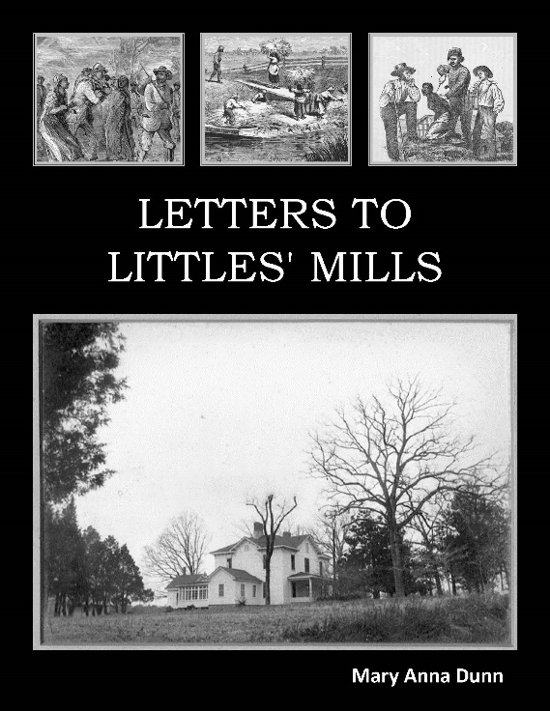
In a work built around real-life words taken from spirituals and the letters of her ancestors, Mary Anna Dunn repositions the languages of a dark time in poems that confront the reader. Dunn’s brilliant sense for sound and rhythm will take you, on every line, through every word, into thought and reflection. —John Most, author most recently of What Thoughts
In Letters to Littles’ Mills, a trinity of angles casts an indelible spell. Mary Anna Dunn not only allows raw history to breathe again, but also conceptualizes it and re-makes it so that we can see clear through to its frailties and follies. Sentiment, and not sentimentality, abounds. Anyone searching for solid ways to come to terms with America’s haunted past will find this book bracing, rewarding, and strangely beautiful.—Douglas Nordfors, author of Auras and The Fate Motif

Part fictive narrative steeped in the historical, part epistolary record, and part songbook of spirituals, Letters to Littles’ Mills gathers a cumulative power as it weaves together seemingly disparate stylistic elements to render another century awash in moral (or immoral) complexity and violence. Dunn has drawn a local habitation in cadences that recreate its people, its customs, and its enduring legacy of grief. —Michael Waters, author most recently of Celestial Joyride
Release Date February 12, 2018
As the descendant of people who enslaved their fellow humans, I wanted to lift my voice not to defend my ancestors as so many Southerners do, but instead to acknowledge the horrors they participated in. I had inherited letters written from 1799 to 1884. In Letters to Littles’ Mills, I interwove excerpts from the letters with spirituals collected by musicologists at around the time of the Civil War and with my own poetry as I imagined the lives of people enslaved by my ancestors. — Mary Anna Dunn

13.99 per copy plus 2.99 shipping
Royalties are determined by sales. If Mary Anna receives royalties or other proceeds from sales, 50% will be donated to educational and anti-poverty programs in the vicinity of Littles’ Mills.
Please send me ___________ copy/copies of Letters to Littles’ Mills.
Name ___________________________________________________________________________________________
Address _________________________________________________________________________________________
City, State, Zip Code ______________________________________________________________________________
______ Enclosed is my check, payable to Finishing Line Press. for $_______________________________________
Please charge my Credit Card $_____________________________
Credit Card Number ______________________________________ CVC __________________________________
Expiration Date __________________________________________ _____ Visa _____ Master Card
Mail to: Finishing Line Press PO Box 1626 Georgetown KY 40324

