POPnPOEMS©
Adaptive Nature Poetry Activity
Begin by playing “Deep in the Meadow” from Hunger Games.
Look at how the describing words are used in the lyrics on the next page. Two describing words are marked in purple. Can you find more? Underline them. Use a purple marker IF you have one.
Go outside and look at nature (trees, flowers, birds, clouds, etc). Or look for pictures of beautiful scenes from nature.
Write down six words to describe what you see. Copy, or have a helper copy, your words onto the blank labels on page 11.

____________________ ____________________ ____________________

____________________ ____________________ ____________________

On pages 4- 7 you will see colorful lines arranged in patterns.
Red lines are naming words (nouns).
Purple lines are for words that describe nouns (adjectives).
Green lines are for acting and being words (verbs).
Blue lines are for words that describe verbs and adjectives (adverbs).
Choose a pattern.
Turn to the Word Bank on pages 8-14. You don’t have to use words from the word bank, but they are there if you need ideas. These words can be printed as labels if you have a printer and mailing labels.
Fill in words that match the color of the lines on your pattern to create a poem.
If you cannot find a word you want to use, write your own word or get someone to help you. Also, you can add endings to your words. In my poem, below, I added “ing” to “flow” and I used the word “dragonfly”, which is not in our labels.

HERE IS ARE SAMPLE INSTRUCTIONS FOR PATTERN ONE.
Pick a red word.
Put it on the red line in the middle of the first row.
Now put a purple word in front of your red word and a green word after your red word. Be sure the three words make sense together.
Keep putting down words to match the colors until you have finished your poem
EXAMPLE
At the Moorman’s River
Cool water flowing.
Birds singing joyfully.
Peaceful stream.
Cool shade.
Beautiful dragonfly fluttering.

Deep in the meadow
Under the willow
A bed of grass
A soft green pillow
Lay down your head
And close your eyes
And when they open
The sun will rise
Here it's safe
Here it's warm
Here the daisies guard
You from every harm

PATTERN ONE Title__________________________________

__________________________________ __________________________________ _________________________________________

__________________________________ __________________________________ _________________________________________

__________________________________ __________________________________

__________________________________ __________________________________

__________________________________ __________________________________ _________________________________________
PATTERN TWO Title__________________________________

________________________ ________________________

________________________ ________________________

________________________ ________________________

________________________ ________________________

________________________ ______________________ ______________________

______________________ ______________________ ______________________

PATTERN THREE Title__________________________________

______________________________________ ______________________________________

______________________________________ ______________________________________

______________________________________ ______________________________________ ______________________________________

______________________________________ ______________________________________

______________________________________ ______________________________________

______________________________________ ______________________________________ ______________________________________

______________________________________ ______________________________________ ______________________________________

______________________________________ ______________________________________ ______________________________________

______________________________________ ______________________________________

______________________________________ ______________________________________

Your Word Bank begins on the next page.
AIR |  | FIELD |  | 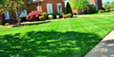  LAWN
BEACH |  | FLOWERS |  | 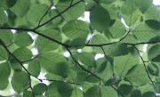  LEAVES
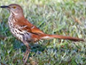  BIRD |  | 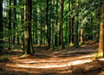  FOREST |  | LIGHT  3
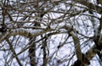  BRANCH |  | 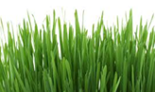  GRASS |  | 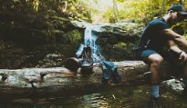  LOGS
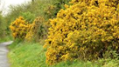  BUSHES |  | 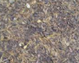  GROUND |  | MAPLE TREE
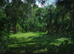  CLEARING |  | 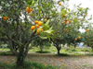  PEACH GROVE |  | 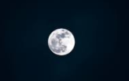  MOON
CLOUD |  | HILL |  | 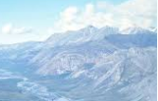  MOUNTAINS
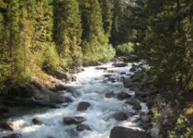  CREEK |  | 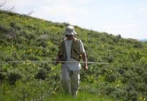  HILLSIDE |  | OCEAN
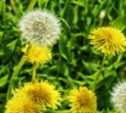  DANDELIONS |  | 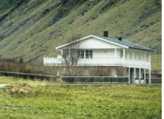  HOUSE |  | 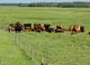  PASTURE
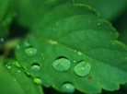  DEW |  | 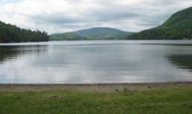  LAKE |  | 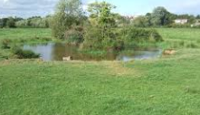  POND
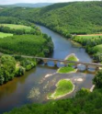  RIVER |  | 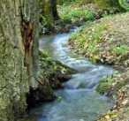  STREAM
ROSE |  | SUMMER
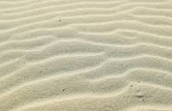  SAND |  | 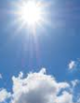  SUN
SEA |  | SUNFLOWERS
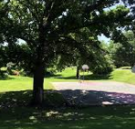  SHADE |  | 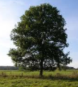  TREE
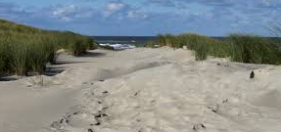  SHORE |  | 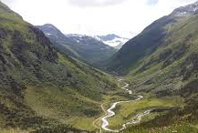  VALLEY
SKY |  | 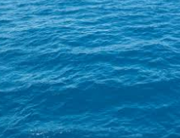  WATER
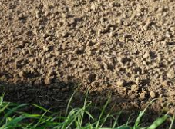  SOIL |  | 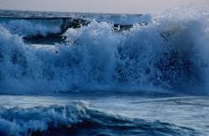  WAVES
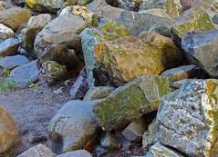  STONES |  | 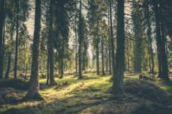  WOODS
BEAUTIFUL |  | GOOD |  | QUIET
BLUE |  | GREEN |  | RED
BRIGHT |  | HAZY |  | SALTY
BROWN |  | HIDDEN |  | SMALL
CALM |  | HOT |  | SWEET
CLEAR |  | LITTLE |  | TALL
COLD |  | LOVELY |  | WHITE
DEEP |  | MISTY |  | WIDE
DELIGHTFUL |  | ORANGE |  | WILD
GOLDEN |  | PEACEFUL |  | YELLOW
APPEAR |  | FLOW |  | IS
ARE |  | FLUTTER |  | MOVE
ARE |  | FLY |  | PLAY
BLOOM |  | GLITTER |  | REST
BLOW |  | GO |  | RIPPLE
BURN |  | GLOW |  | RISE
DANCE |  | GROW |  | ROLL
FALL |  | HAS |  | SHINE
FLAP |  | HAVE |  | SING
FLOAT |  | IS |  | SMELL
STAND |  |  |  | BEAUTIFULLY
STAY |  |  |  | GENTLY
STOP |  |  |  | JOYFULLY
SWAY |  |  |  | LIGHTLY
TURN |  |  |  | PEACEFULLY
WALK |  |  |  | PLAYFULLY
WAS |  |  |  | SLOWLY
WERE |  |  |  | SWEETLY
WHIRL |  |  |  | QUIETLY
WHOOSH |  |  |  | WILDLY

